QUESTION 3

AIM:
To create a table named `DEPARTMENT` with columns `DeptNo`, `DeptName`, and `DeptHead` using DDL statement.

PROCEDURE:
1. Open the SQL database terminal/client.
2. Execute the `CREATE TABLE` command specifying table name `DEPARTMENT` and defined data types for each attribute.
3. Verify the creation using `DESC DEPARTMENT;`.

CODE / SQL QUERY:

CREATE TABLE DEPARTMENT (
DeptNo VARCHAR(4),
DeptName VARCHAR(15),
DeptHead VARCHAR(4)
);

Output:

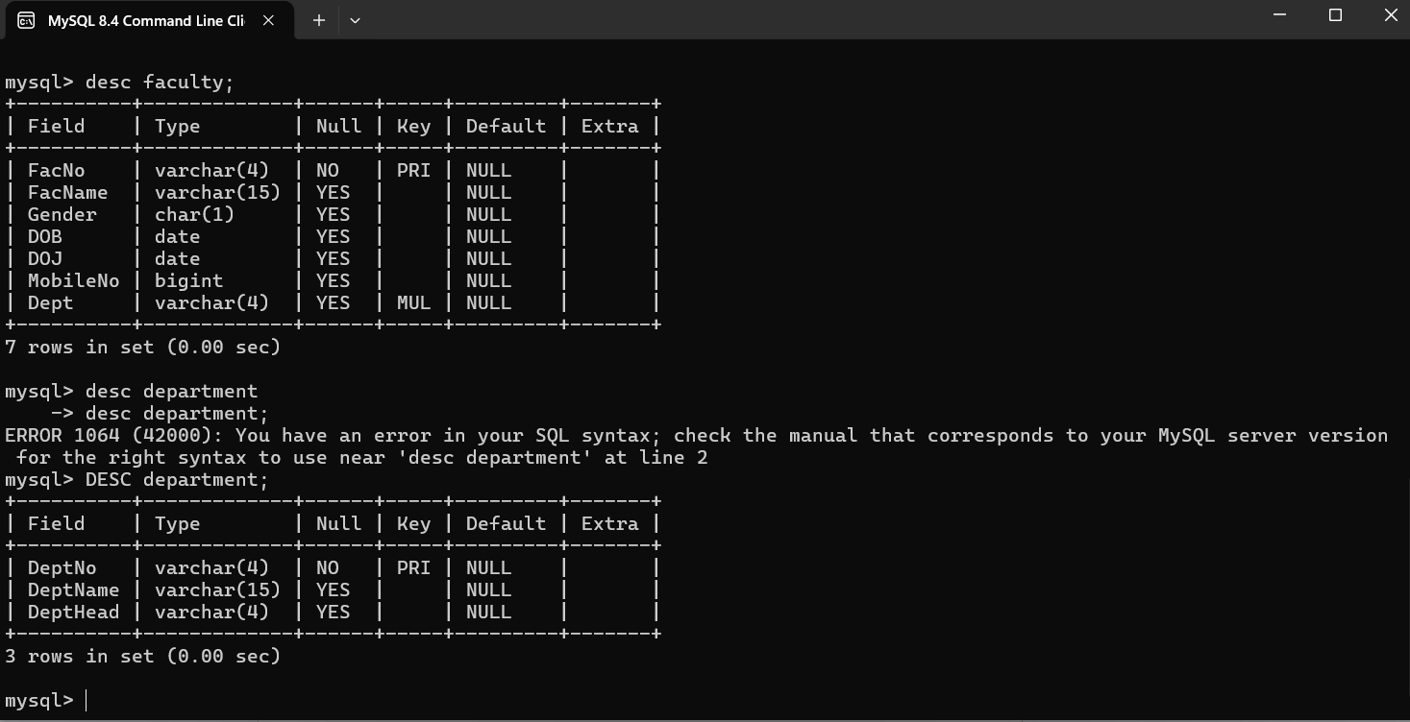 Result
The `DEPARTMENT` table has been created successfully with the required columns and data types.

